Topic: Evaluate the 2018 Colon & Rectal Cancers to determine if they were appropriate to receive and did or did not receive MSI testing or KRAS, NRAS, BRAF testing per the NCCN Guidelines:

- All metastatic colorectal cancer should have tumor tissue genotyped for RAS (KRAS and NRAS) and BRAF mutations. Patients with any known KRAS mutation or NRAS mutation should not be treated with either cetuximab or panitumumbab.
- MSI testing is recommended in all patients with a personal history of colon or rectal cancer.
  - Stage 2 SMI-H patients may have a good response and do not benefit from 5fu adjuvant therapy.
  - Testing for MSI may be accomplished with a validated NGS panel, especially in pts w/met ds who require genotyping of RAS and BRAF.

From Jan thru October of 2018, when this study was performed, there were 23 colon and rectal cancers identified in the Registry database. The Kaiser patients were not included as they routinely order these tests.

Sigmoid | 9
Rectosigmoid | 4
Rectum | 1
Descending Colon | 1
Ascending Colon | 5
Cecum, ICV | 2
Colon, nos | 1
Total | 23
Stage I | Rectosig | 1
Stage II | Sigmoid | 1
 | RectoSig | 1
 | A Colon | 2
Stage III | Sigmoid | 3
 | Rectum | 1
Stage IV | Sigmoid | 5
 | Rectosig | 2
 | A Colon | 2
 | Cecum | 2
 | Colon NOS | 1
Unknown Stg | D Colon | 1
 | A Colon | 1
 |  | 23

Many of the patients had ongoing symptoms, many for months, which included anemia, bloody stools and abdominal pain. Of the newly diagnosed first primary patients none of them had a prior colonoscopy.

The ages of the 23 patients ranged from 33 to 86, with an average of 62 years of age. The average age is 68 for colorectal cancer according to NCI Data. https://www.cancer.gov/about-cancer-prevention/risk/age

Comparison between 2014 California Cancer Facts & Figures and AIS Cancer Stats:
AIS Males 2017 | 14 or 61% | AIS Females 2017 | 9 or 39%
Calif Males 2014 | 7,770 or 54% | Calif Females 2014 | 6,654 or 46%
Comments: There were 8 Hispanic patients, 13 Caucasian patients, 1 Asian and 1 African American.

According to the ACS, California Facts & Figures for 2017 only 42% of colorectal cancer are diagnosed in an early stage. Comparing our cases to NCI data, we had a significantly higher percent of cases diagnosed with distant disease.

 | Stage I | Stage II | Stage III | Stage IV | Unknown
AIS 2018 | N=1  7% | N=2  13% | N=4  27% | N=7  47% | N= 1  7%
NCI Colon 2014 | Local 40% |  | Regional 32% | Distant 23% | Unknown  5%
NCI Rectal  2014 | Local 43% |  | Regional 34% | Distant 18% | Unknown 5%

Of the 12 patients that had surgery for their newly diagnosed colorectal cancers, 3 (25%) had < 12 regional lymph nodes removed while 9 or 75% had 12 or more lymph nodes resected. The Commission on Cancer CP3R performance rate is >80%. See Recommendation 1:

Days from Diagnosis To Surgery:
Diagnosed at Surgery | 5
Diagnosed & surgery next day | 2
3 days | 1
7 days | 1
10 days | 1
27 days | 1
32 days | 1
Unknown | 4
No Surgery | 7

Most patients (10) who received surgery did so within 10 days of the diagnosis, 7 patients did not receive surgery 2nd to metastatic disease and in 4 cases their surgery information is not available to review. They were diagnosed here and treated elsewhere.

Of the patients that were referred to the AIS Cancer Center for additional therapies, all had MSI/KRAS testing except 1
case. Mr. E had been diagnosed in 2015, had a recurrence in 2017 and 2nd primary diagnosed in 7/2018. No record of MSI testing can be located in the medical record. Consultation will be conducted with the medical oncologist to document plan for treatment. One patient of the 12 had a positive result and was treated with FOLFOX.

The California Cancer Facts & Figures, 2017 publication graphically demonstrates the 5 year survival rates for colon and rectal cancer by SEER (Surveillance, Epidemiology and End Results) Summary stage. When if diagnosed with local disease the 5 year survival for Californians was 92% vs 14% for distant disease at the time of diagnosis.

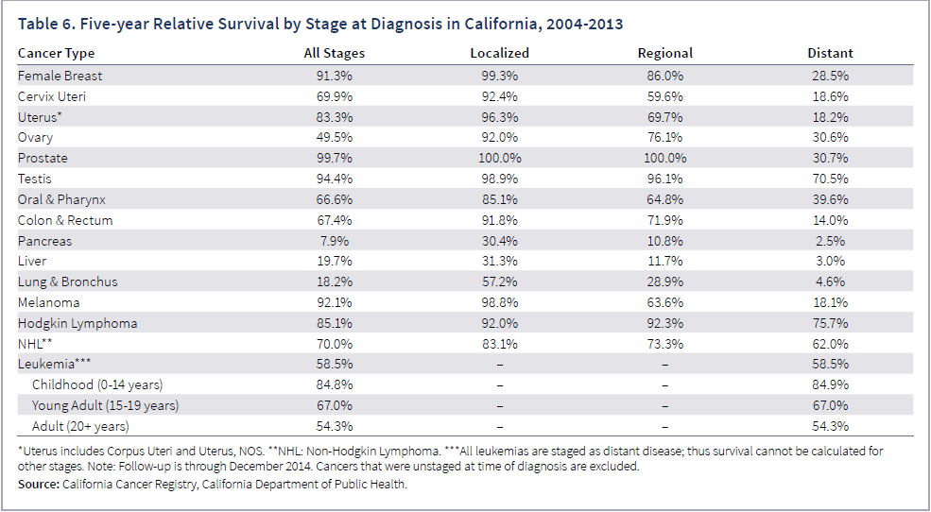

Of the 16 cases of newly diagnosed primary colorectal cancer 8 or 50% were stage IV. None of the 8 cases reported having had a colonoscopy. According to the California Cancer Facts & Figures, 2017, “Persons in poverty” screening rate was 34% for males & 38% for females. Only 19% of Californians older than 50 years old reported having a FOBT and only 16% of Hispanics. See Recommendation 2c.

Many patients reported having anemia, change in bowel habits or abdominal pain prior to diagnosis. The majority of the Stage IV patients reported not having a Primary Care Physician.

Study Results:
- The patients that were diagnosed and treated at the AIS Cancer Center were treated according to the NCCN Guidelines regarding MSI and KRAS testing for their newly diagnosed colorectal cancers.
- Twenty five percent of the colorectal surgeries had less 12 lymph nodes resected as recommended by the College of Surgeons.
- The Stage IV rate of diagnosis is above the national average.

Recommendations:
- Continue to follow the NCCN Guidelines by providing MSI and KRAS testing for colorectal cancer patients to assist in the determination of the most appropriate treatments
- Remind surgeons/medical staff of the College of Surgeons recommendations for the removal of at least 12 regional lymph nodes at the time of surgery for the purpose of adequate staging.
- Focus additional resources on providing low cost noninvasive colon cancer screening testing to persons without PCPs or of low income.
- Develop methods to increase participation in returning test kits:
  - Provide resources for people in need to obtain appropriate healthcare; PCPs, Clinics, Insurance, etc.
  - Collaborate with other healthcare providers to increase the screening rates for colon cancer. (NCQA Reported Average Performance: Commercial Health Plans 55.1%, Medicare Health Plans 49.3%)

Ather Mehboob, MD

